# **Running Food_recommendation project**

1. After cloning the project open the terminal and open the directory where docker-compose file is present. Now enter “docker-compose up”.

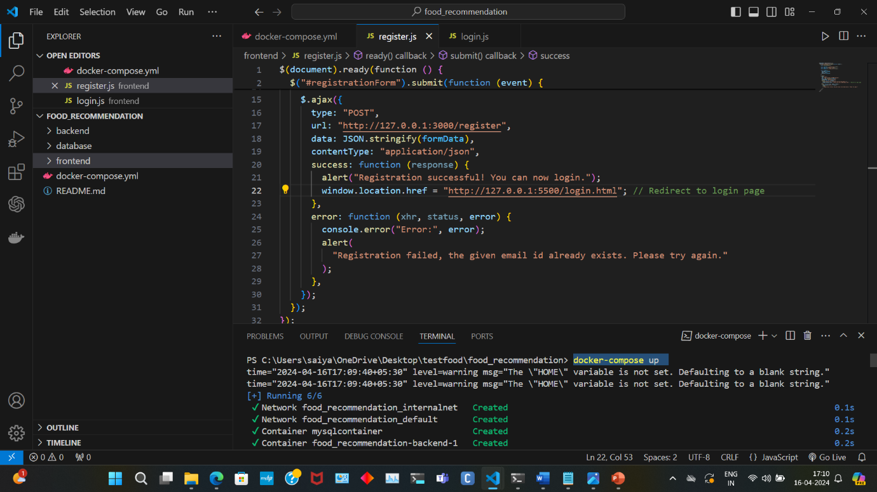

1. And now you can see the containers running in docker desktop application.

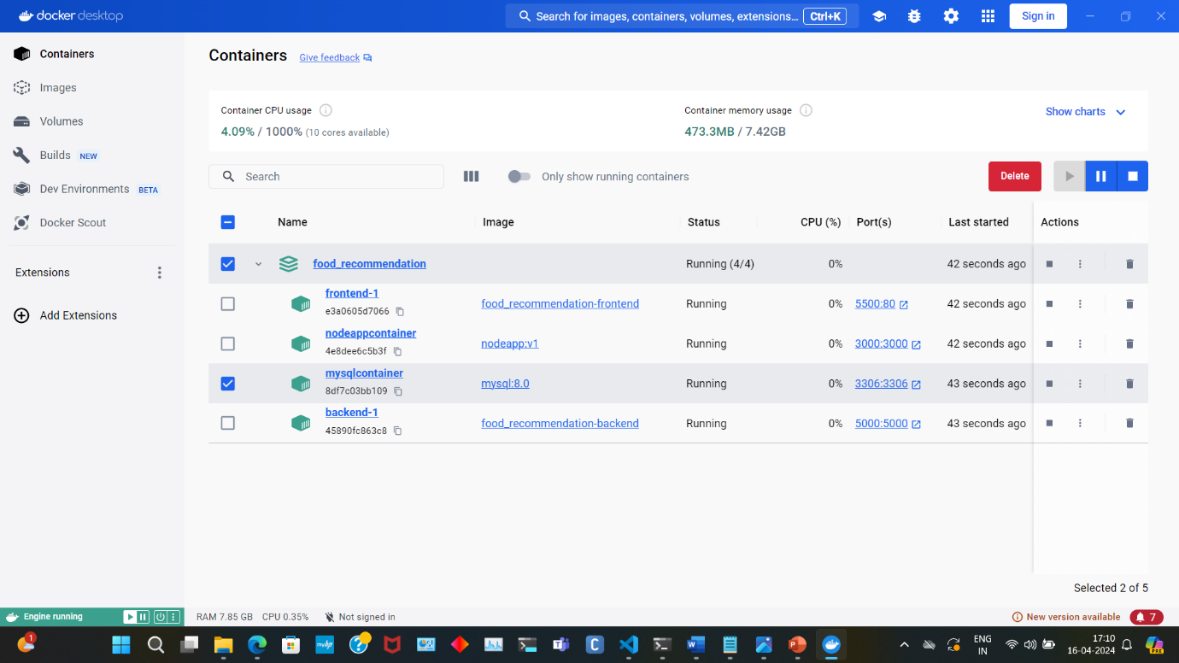

1. In browser run the frontend using <http://localhost:5500/register.html>.
2. Now enter the details and get registered.

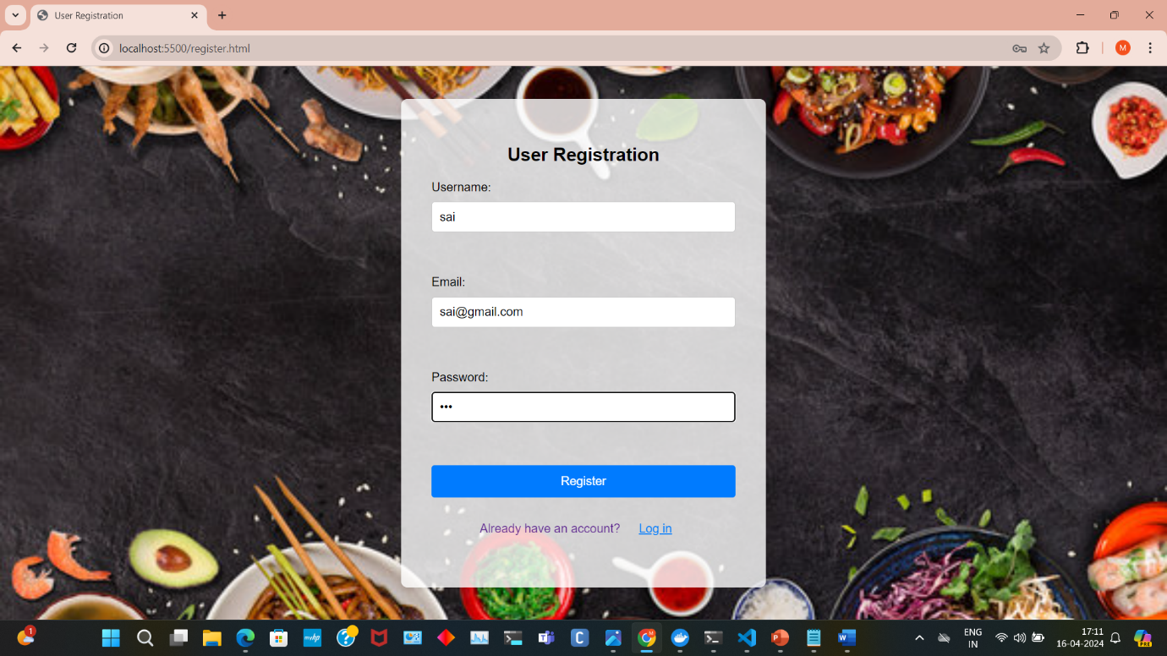

1. Now get logged in.

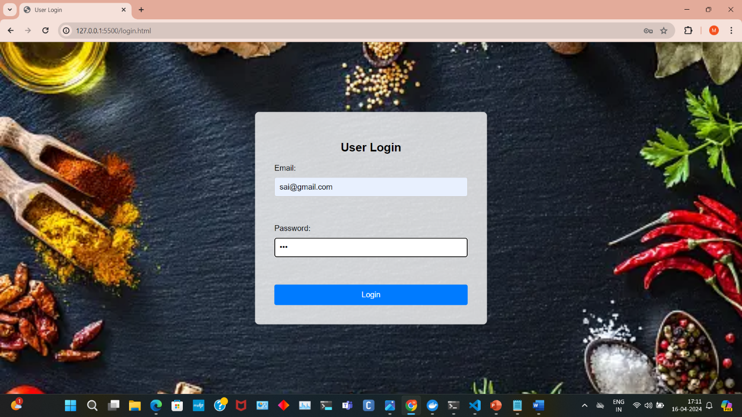

1. Now fill the form for the recommendation.

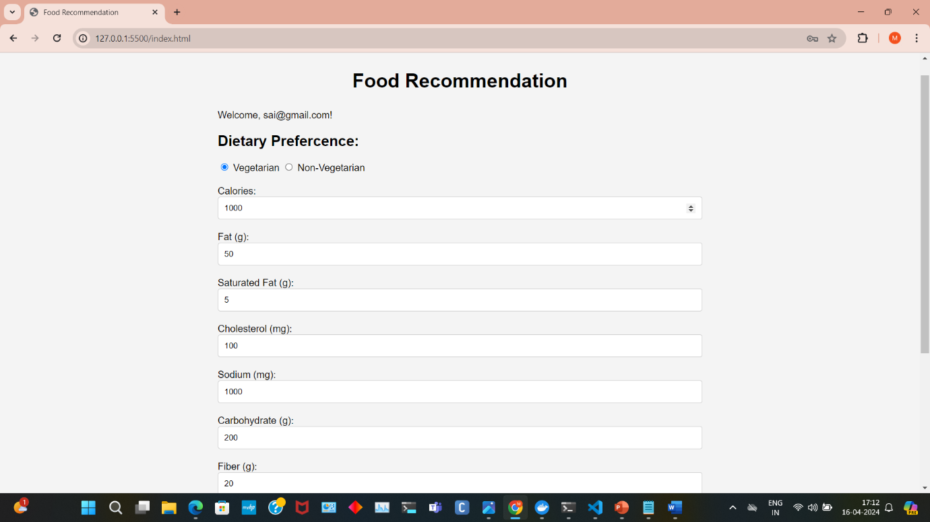

1. In below image you can see recommendations.

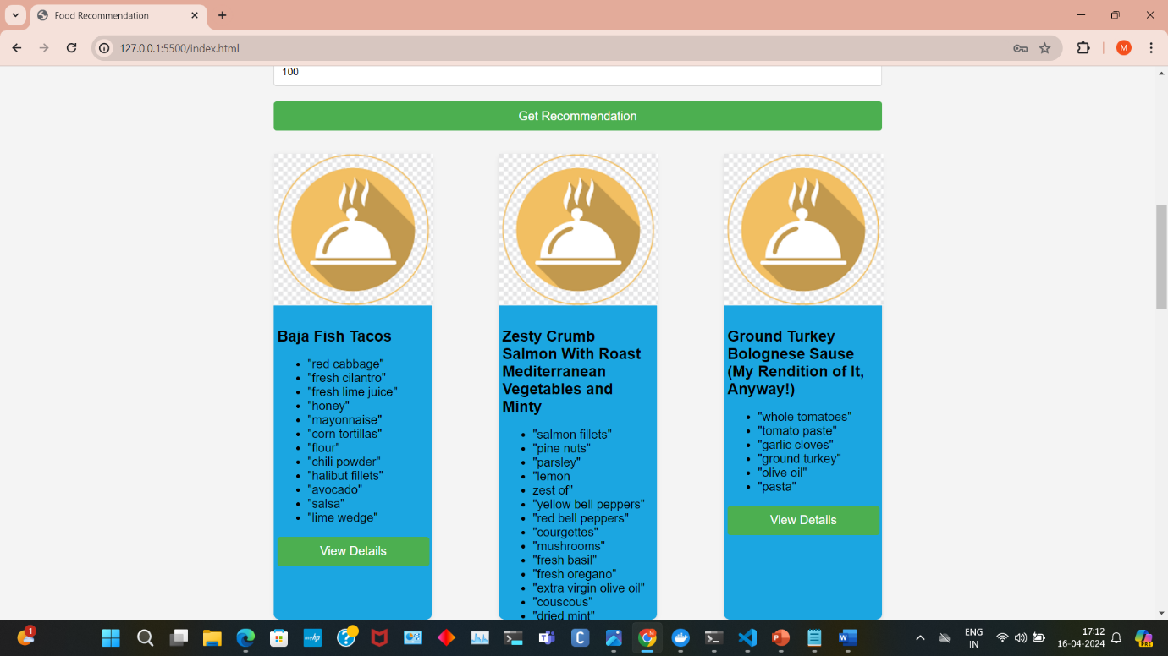

1. Enter the view details button and you can see the alert box listing out the details.

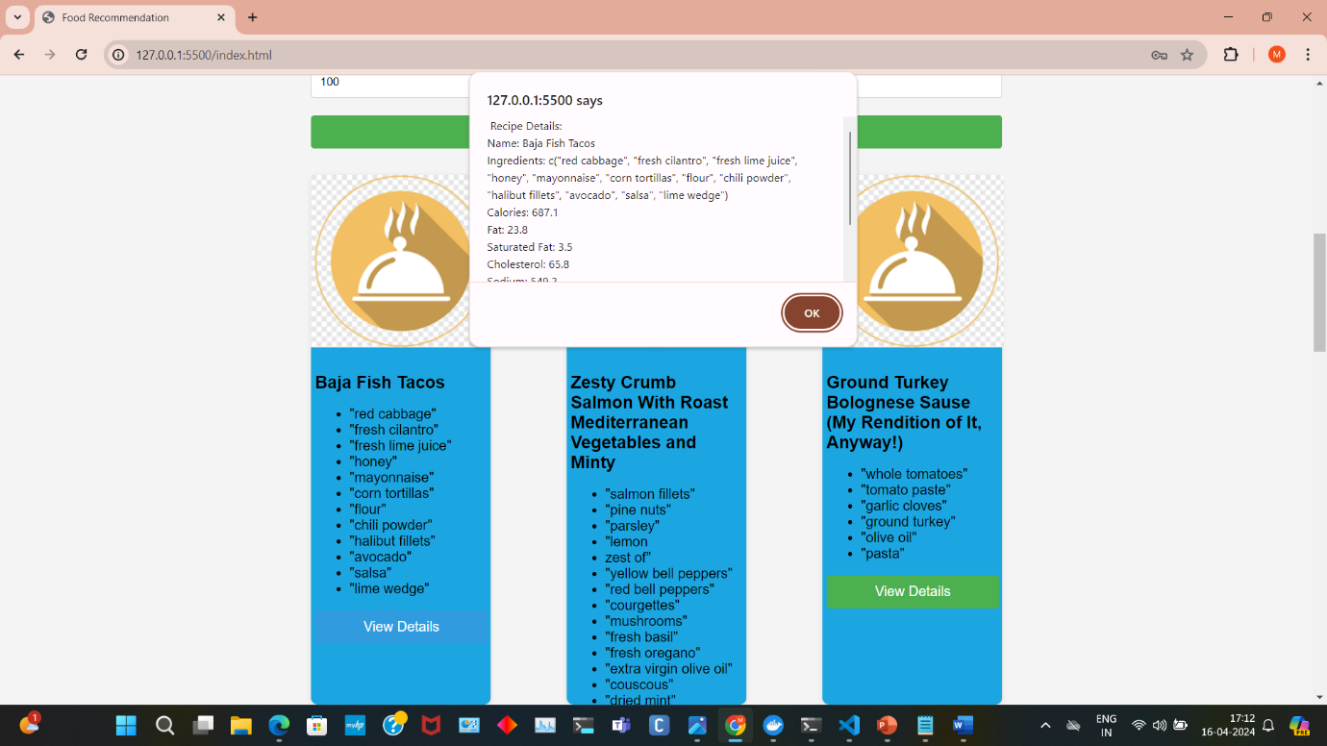

1. Click save all button and click get records button, you can see the saved details.

